Name: Jai Anish Mehta SBU id: 114834757 Course: CSE 534 (FCN)

ASSIGNMENT 1/ HOMEWORK 1

**PART C**

In this part, I ran the dig command using the DNS resolver that we created, using the local DNS resolver and using Google’s DNS to resolve queries.

Local DNS IP: '130.245.255.4'

Google DNS IP: '8.8.8.8', '8.8.4.4'

The top 25 websites chosen are given in the list below.

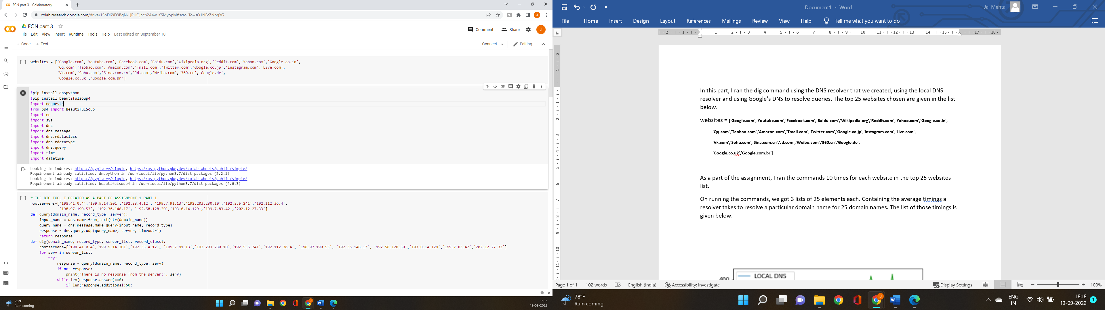

As a part of the assignment, I ran the commands 10 times for each website in the top 25 websites list.

On running the commands, we got 3 lists of 25 elements each. Containing the average timings a resolver takes to resolve a particular domain name for 25 domain names. The list of those timings is given below.

Time for the resolver I created in part A

[44.3, 44.1, 54.4, 260.6, 69.2, 54.2, 54.4, 76.0, 283.4, 91.9, 97.1, 92.0, 134.5, 205.7, 62.5, 71.3, 324.4, 270.7, 411.4, 281.9, 266.0, 418.8, 184.0, 184.3, 198.9]

Time using the local DNS

 [9.7, 9.9, 10.1, 12.0, 9.7, 9.2, 29.0, 15.7, 33.3, 14.1, 12.0, 8.9, 9.1, 11.9, 12.3, 8.7, 10.1, 11.3, 280.9, 8.8, 69.3, 106.7, 9.9, 11.5, 8.0]

Time using the Google DNS

 [12.5, 8.1, 7.9, 12.0, 7.0, 10.1, 14.0, 7.9, 10.1, 8.9, 13.1, 14.0, 14.9, 7.1, 7.9, 16.0, 10.0, 12.1, 12.0, 12.0, 8.9, 14.1, 215.0, 20.0, 217.0]

**OBSERVATION**

When I plotted these timings on a graph with 3 different coloured markers for the 3 lists above. I got the output as shown below.

The y-axis of the output represents the resolution time taken in milliseconds.

The x-axis represents the top 25 websites chosen for the experiment.

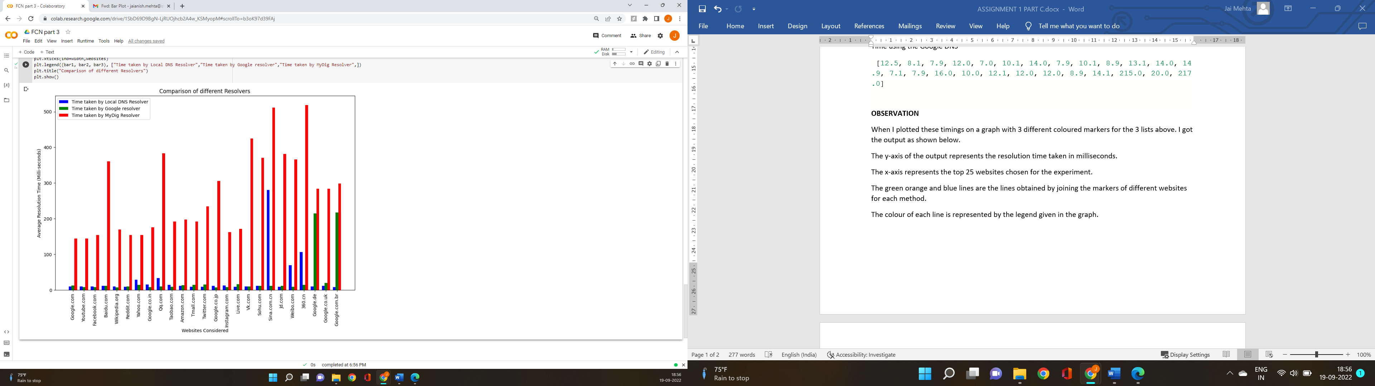

From the above graph is evident that:

* The dig resolver created by me uses the highest amount of time to resolve a query
* In most cases, local DNS takes the least amount to resolve a query.
* Google DNS resolution approximately lies between the other two.

The reason for the above observations is that the local DNS has caching mechanism which helps it significantly in cutting down long round trips thereby reducing the resolution time. Similarly, google DNS too might be having a caching mechanism, but it is possible due to the proximity it does not perform as good as the local DNS.